A minimum problem
Find the shortest distance from the origin O to the curve $y=\frac{1}{x^{4}}$ (where x > 0).
Use the following methods:
(1) Calculus,
(2) A.M.≥ G.M.

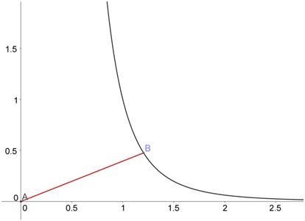


(1) Calculus:
Method 1
$s=AB=\sqrt{{\left(x-0\right)}^{2}+{\left(y-0\right)}^{2}}=\sqrt{x^{2}+y^{2}}=\sqrt{x^{2}+{\left(\frac{1}{x^{4}}\right)}^{2}}=\sqrt{x^{2}+\frac{1}{x^{8}}}$
${s^{2}=x}^{2}+\frac{1}{x^{8}}$
$2s\frac{ds}{dx}=2x-\frac{8}{x^{9}}⇒\frac{ds}{dx}=\frac{1}{s}\left(\frac{x^{10}-4}{x^{9}}\right)$
For critical points, $\frac{ds}{dx}=0$.
$x^{10}-4=0⟹ x=\sqrt[10]{4}=\sqrt[5]{2}≈1.148698354997$
For $0<x<\sqrt[5]{2}, \frac{ds}{dx}<0$. and for $x>\sqrt[5]{2}, \frac{ds}{dx}<0$.
Therefore y is a minimum when $x=\sqrt[5]{2}$.
When $x=\sqrt[5]{2},$
$s=\sqrt{{\left(\sqrt[5]{2}\right)}^{2}+\frac{1}{{\left(\sqrt[5]{2}\right)}^{8}}}=\sqrt{\frac{{\left(\sqrt[5]{2}\right)}^{10}+1}{{\left(\sqrt[5]{2}\right)}^{8}}}=\sqrt{\frac{4+1}{\sqrt[5]{256}}}=\sqrt{\frac{5}{\sqrt[5]{256}}}=\sqrt[10]{\frac{3125}{256}}≈1.2842838037078$
Method 2
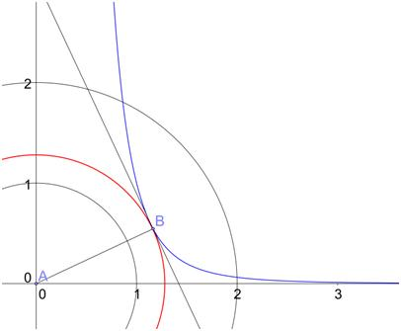
Construct a circle centre origin and radius r : $x^{2}+y^{2}=r^{2}$ …. (1)
Common tangent
Too big circle, two intersection points
Too small circle, no intersection point
In order to find the shortest r, we like to have this circle touches the given curve:
$y=\frac{1}{x^{4}}$ …. (2)
Then (1) and (2) should have a common tangent
at the point of contact .
Differentiate (1) and (2),
$$\left\{\begin{aligned} 2x+2y\frac{dy}{dx}=0 ⟹ \frac{dy}{dx}=-\frac{x}{y} \\ \frac{dy}{dx}=-\frac{4}{x^{5}}\end{aligned}\right.$$
$∴ -\frac{x}{y}=-\frac{4}{x^{5}} ⟹ y=\frac{x^{6}}{4}$ …. (3)
By (2), $\frac{1}{x^{4}}=\frac{x^{6}}{4} ⟹ x^{10}=4 ⟹ x=\sqrt[10]{4}=\sqrt[5]{2}≈1.148698354997$
By (3), $y=\frac{{\left(\sqrt[5]{2}\right)}^{6}}{4}$
By (1), ${r^{2}=x}^{2}+y^{2}={\left(\sqrt[5]{2}\right)}^{2}+{\left[\frac{{\left(\sqrt[5]{2}\right)}^{6}}{4}\right]}^{2}≈1.6493848884661$
$r≈1.2842838037078$

(2) A.M.≥ G.M. :
$s=AB=\sqrt{{\left(x-0\right)}^{2}+{\left(y-0\right)}^{2}}=\sqrt{x^{2}+y^{2}}=\sqrt{x^{2}+{\left(\frac{1}{x^{4}}\right)}^{2}}=\sqrt{x^{2}+\frac{1}{x^{8}}}$
$=\sqrt{\frac{x^{2}}{4}+\frac{x^{2}}{4}+\frac{x^{2}}{4}+\frac{x^{2}}{4}+\frac{1}{x^{8}}}≤\sqrt{5\sqrt[5]{\left(\frac{x^{2}}{4}\right)\left(\frac{x^{2}}{4}\right)\left(\frac{x^{2}}{4}\right)\left(\frac{x^{2}}{4}\right)\left(\frac{1}{x^{8}}\right)}}$ (A.M. ≥ G.M.)
$=\sqrt{5 \sqrt[5]{\frac{1}{256}}}=\sqrt[10]{\frac{3125}{256}}≈1.2842838037078$
The point is to get rid of all x !
where equality holds if and only if
$\frac{x^{2}}{4}=\frac{1}{x^{8}} ⇔ x^{10}=4 ⇔ x=\sqrt[10]{4}=\sqrt[5]{2}≈1.148698354997$
Yue Kwok Choy
12 June, 2015

